Github url: https://github.com/wingftsui/COMP3010HK-CW2
(A) Introduction
This report using the view of “Forthly” company’s Security Operations Centre (SOC) lead to analyze the Cyber Kill Chain(CKC) of incident data (BOTSv3).
Part (B) reflects the SOC tiers on BOTSv3 incident. It also discuss the incident handling phrases.
Part (C)
Part (D) analysis the BOTSv3 guided questions.
Part (E) is the conclusion.
(B) Soc Roles & Incident Handling
Part (D) will use the view of SOC tier2. Part (E) will use the view of SOC tier3
Prevention
M
Detection
It is I reconstruct the case details by using splunk. The system does not auto detect the problem (public access S3 bucket) or give out any warning to bud.
Response
Bud
Recovery

(C) Installation and Data Preparation
Splunk are used for the detection of this analysis report. Splunk is installed in Ubuntu in VM vitualBox.(Fig INS_1, INS_2) Running Splunk in ubuntu can save 2GB RAM compare with running in Windows. It is because ubuntu has fewer GUI and background running services.
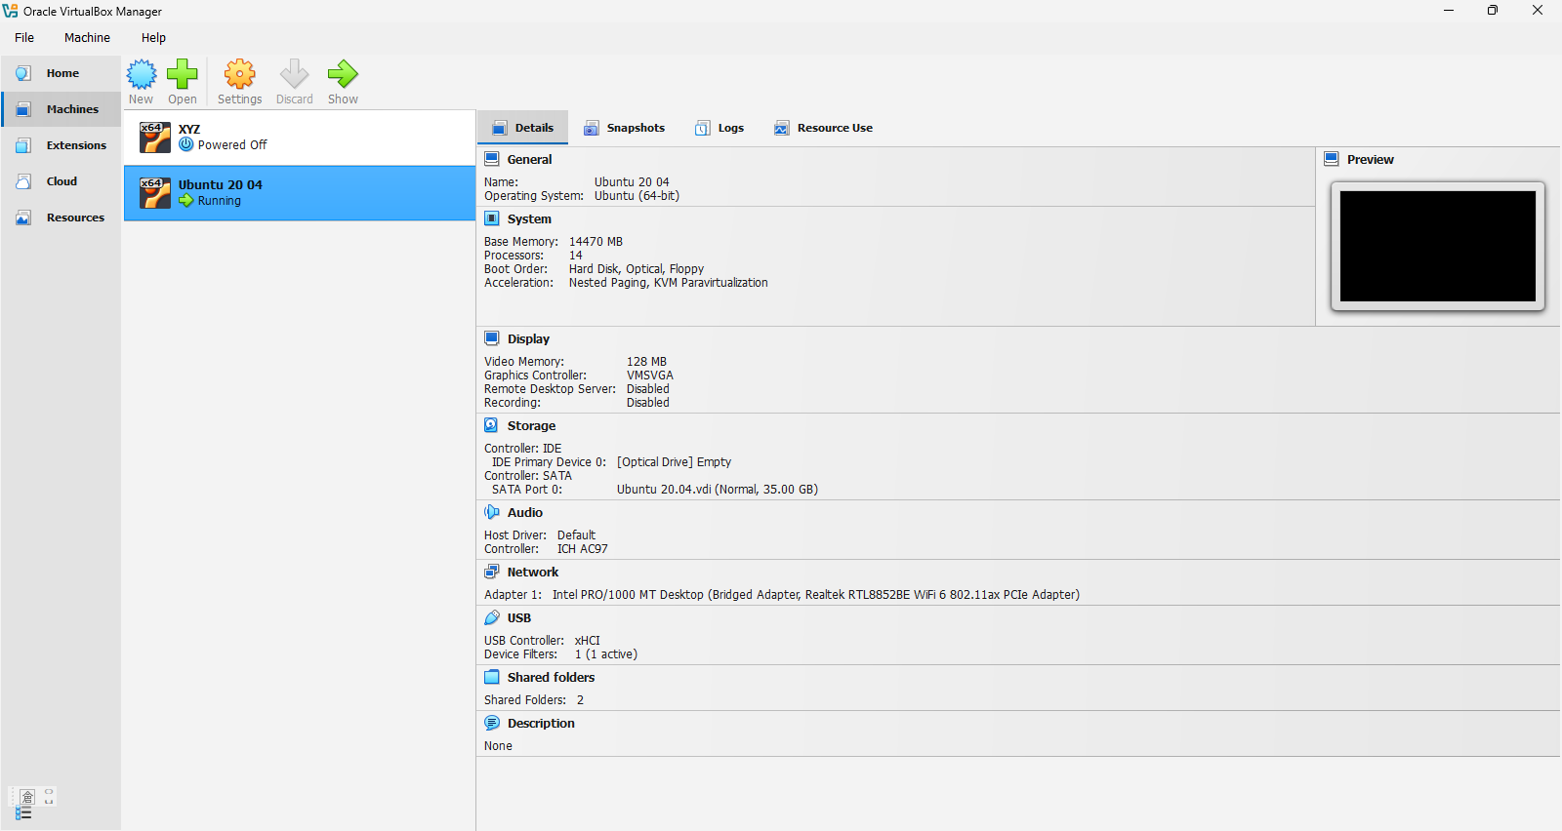Fig INS_1
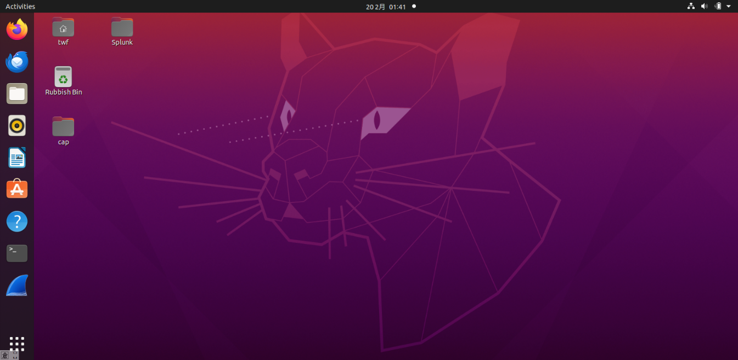 Fig INS_2
Running the script in terminal to ensure the Ubuntu’s safety quit(Fig.INS_3). It is to avoid crash in Ubuntu.
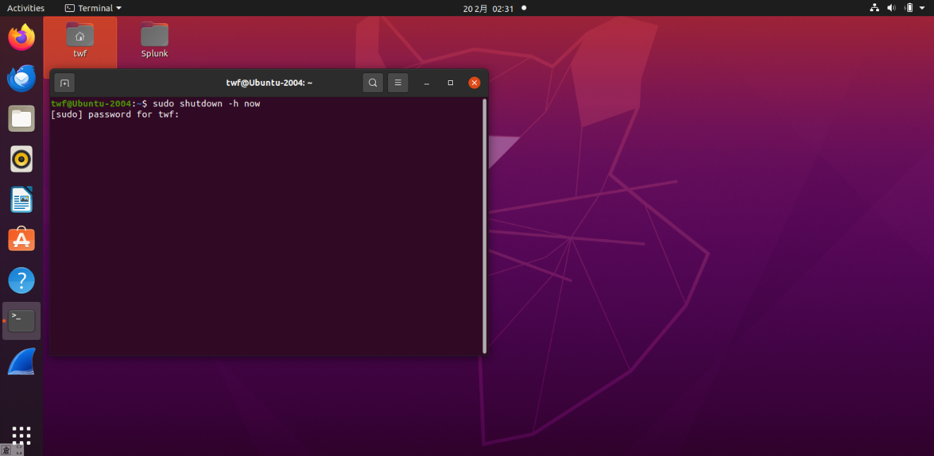 Fig INS_3
After installing splunk and importing the BOTSv3 into it, I run “index=botsv3 earliest=0” to check the data integrity. There are 2,083,056 events (Fig INS_4) which is larger than 2,030,269 events [2]. Therefore, it is okay.
(D) Guided Questions
Overview:
This set of 8 guided questions includes 3 phrases. Phrase 1(Q1 to Q6) is cloud oversight leads to vulnerable environment. The turning point(Q4-Q6) occurs when Bud accidentally makes an S3 bucket public. It is human negligence that leads to insider threats. Phrase 2 (Q7) describes exploitation, where the attacker discovers this publicly accessible S3 bucket. Phrase 3 (Q8)

Q1
Query:
index=botsv3 earliest=0 sourcetype="aws:cloudtrail" userIdentity.type=IAMUser
| stats count by userIdentity.userName
Result (Fig.SO_CW2_Q1A):
Bstoll, btun, splunk_access, web_admin
Explanation and SOC relevance:
Using the query to search for the IAMUser that access the AWS service, bud is the main character of the whole incident. In addition, Bstoll has the activities "GetBucketAcl" (query: index=botsv3 earliest=0 sourcetype="aws:cloudtrail" | stats count by userIdentity.userName, eventName | sort – count)(results:fig.SO_CW2_1B) together with the “PutBucketAcl” in Q4 create a vulnerability for the attacker to take advantage of.
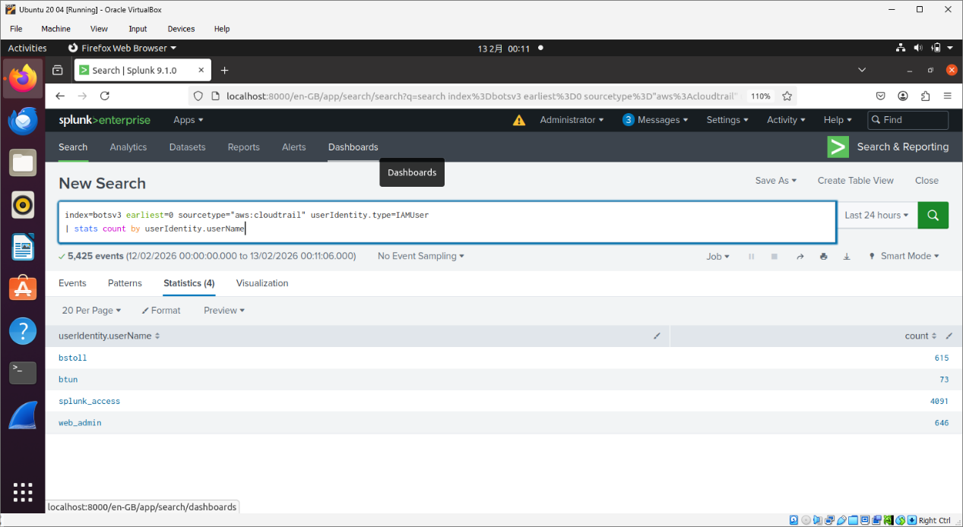Fig.SO_CW2_Q1A
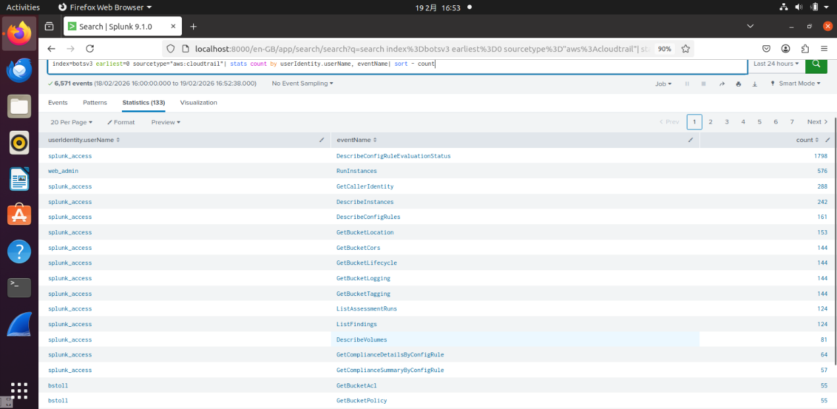 Fig.SO_CW2_Q1B
Q2
Query:
index=botsv3 earliest=0 sourcetype="aws:cloudtrail"
Results(Fig.SO_CW2_Q2A):
userIdentity.sessionContext.attributes.mfaAuthenticated
Explanation and SOC relevance:
“userIdentity.sessionContext.attributes.mfaAuthenticated” is used to determine whether the AWS service has MFA. And it is found that they are without MFA. (Fig.SO_CW2_Q2B) It is a weak link that can be exploited by an attacker
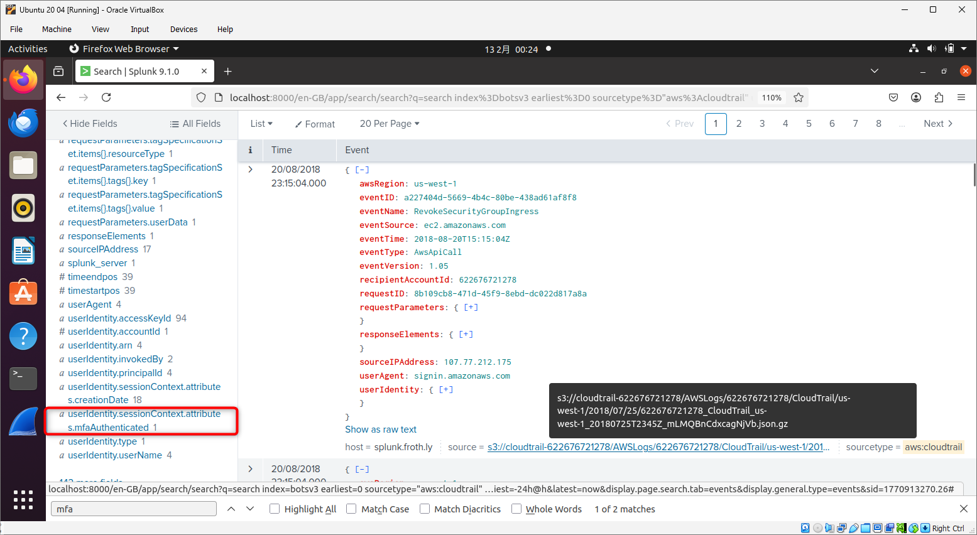 Fig.SO_CW2_Q2A
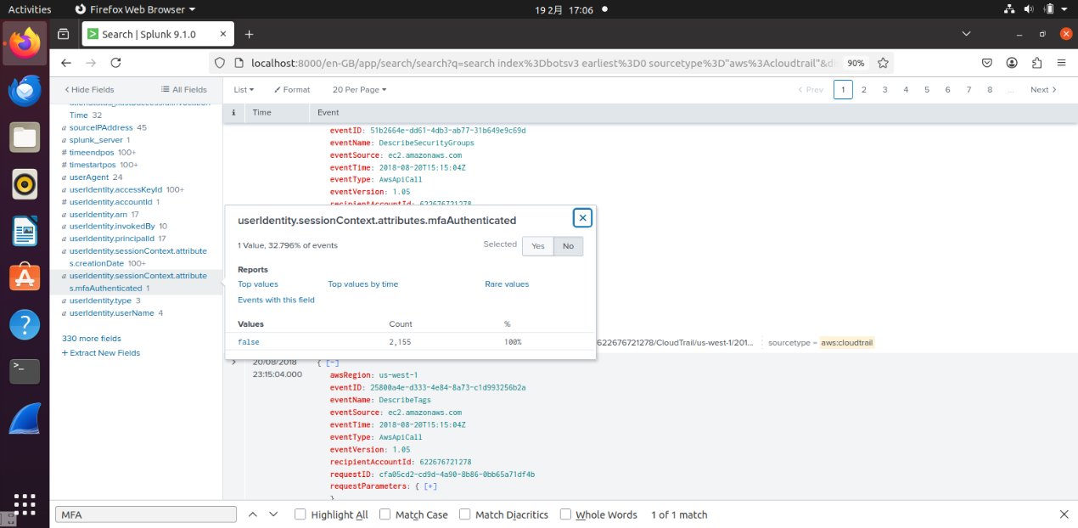 Fig.SO_CW2_Q2B
Q3
Query:
index=botsv3 earliest=0 sourcetype="hardware"
Results(Fig.SO_CW2_Q3):
E5-2676
Explanation and SOC relevance:
The processor number in the web server is important. It is because is the web server may serves as the attacker's base, but not this time (the bud incident).
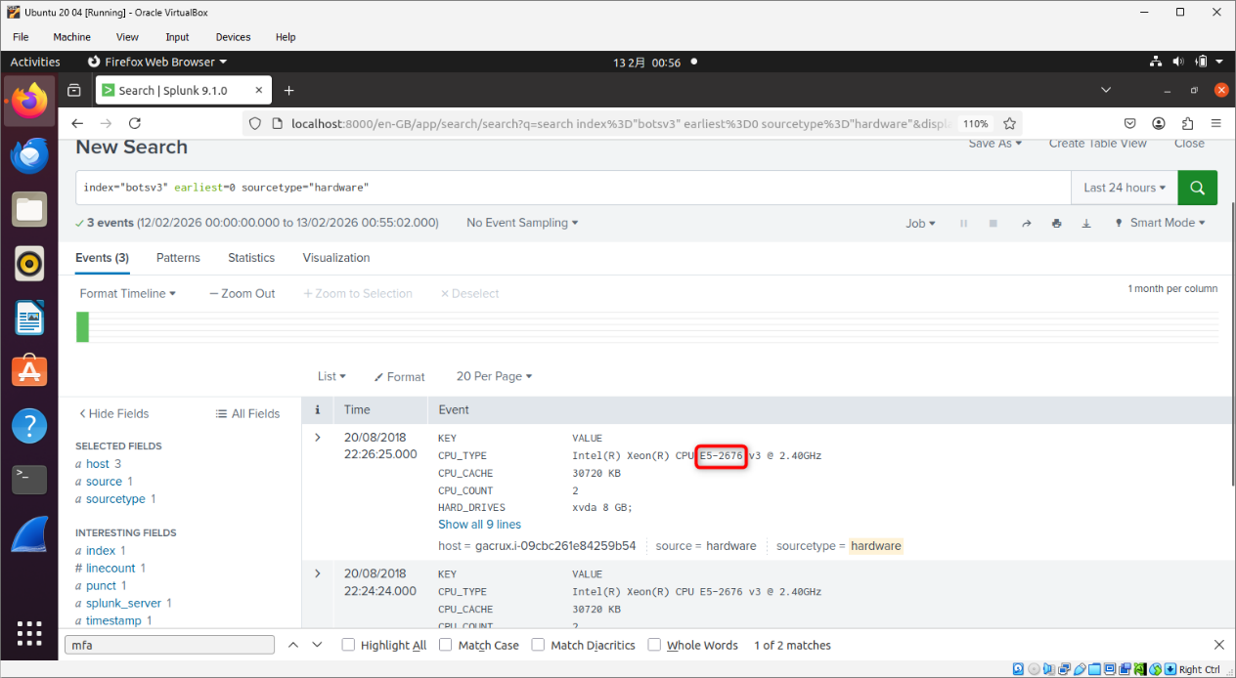 Fig.SO_CW2_Q3
Q4
Query:
index=botsv3 earliest=0 sourcetype="aws:cloudtrail" "PutBucketAcl"
Results (Fig.SO_CW2_Q4A):
ab45689d-69cd-41e7-8705-5350402cf7ac
Explanation and SOC relevance:
"PutBucketAcl" is the API call to update the access right in the S3 bucket. This event involves Bud accidentally making S3 bucket public. The attackers can use this open door to attack S3 bucket. After running the above query, there are 2 events. There are 2 reasons that the lower event is the bud incident:
(i) it occurs earlier. (ii) In the payload, it has the wording "AllUsers"(Fig.SO_CW2_Q4B) which in turn meaning the bucket is publicly accessible.
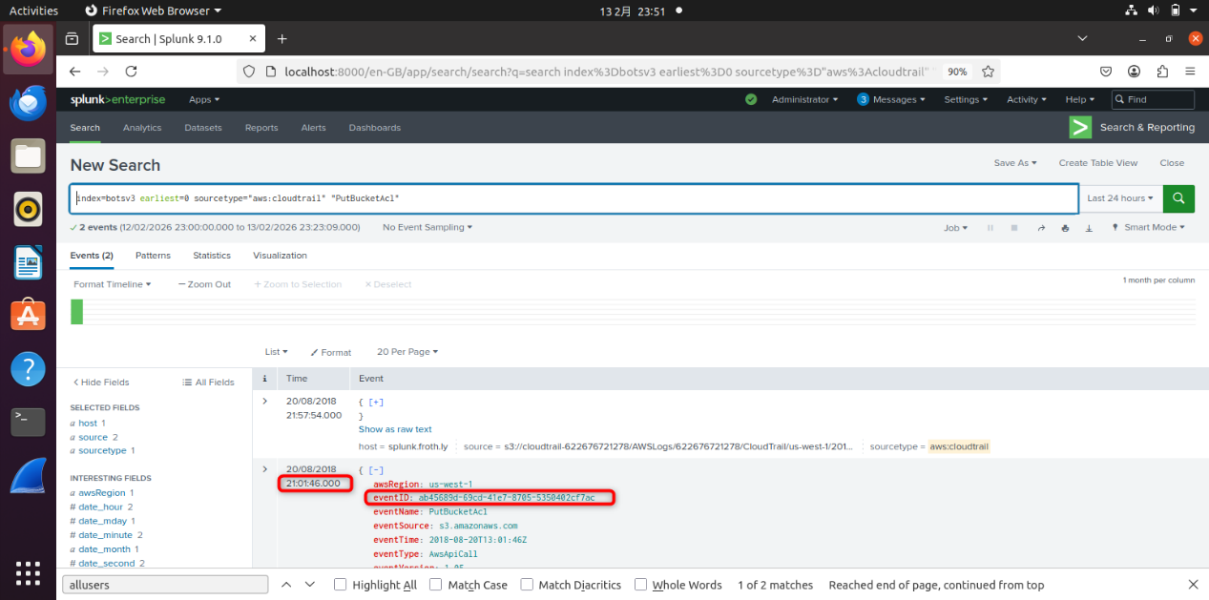 Fig.SO_CW2_Q4A

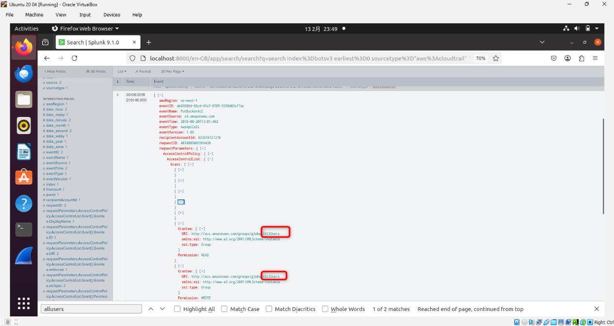 Fig.SO_CW2_Q4B
Q5
Query:
index=botsv3 earliest=0 sourcetype="aws:cloudtrail" "PutBucketAcl"
Results(Fig.SO_CW2_Q5):
Bstoll
Explanation and SOC relevance:
This user is the main character of the whole bud incident. His fault leads to S3 bucket being attacked.
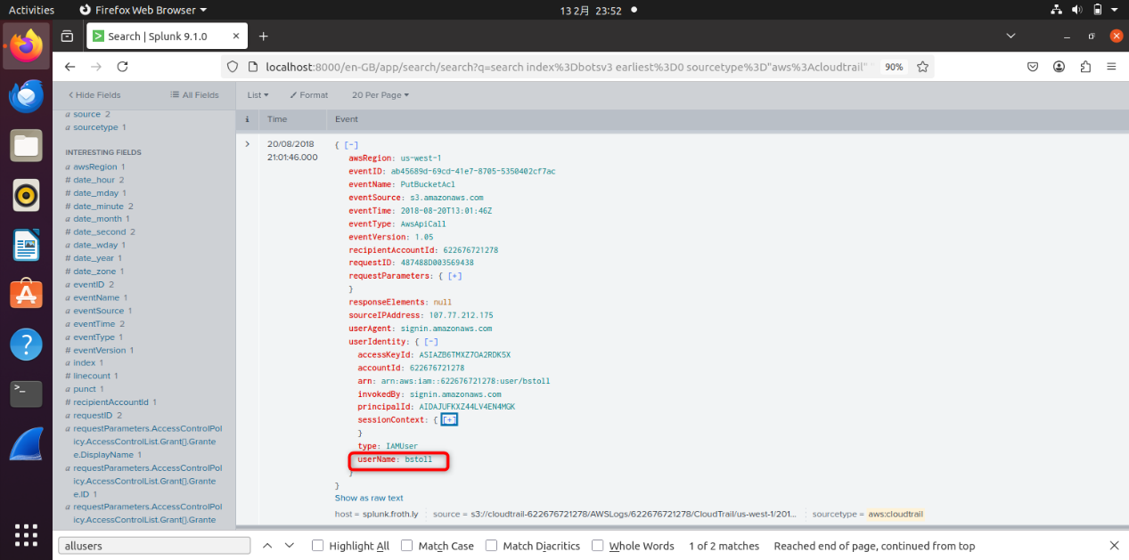 Fig.SO_CW2_Q5
Q6
Query:
index=botsv3 earliest=0 sourcetype="aws:cloudtrail" "PutBucketAcl"
Results(Fig.SO_CW2_Q6):
frothlywebcode
Explanation and SOC relevance:
Using the same query as Q4 and Q5, can found the incident’s S3 bucket name. “frothlywebcode” may become the attack target of the attacker or may be used as lateral movement in the cyber kill chain.

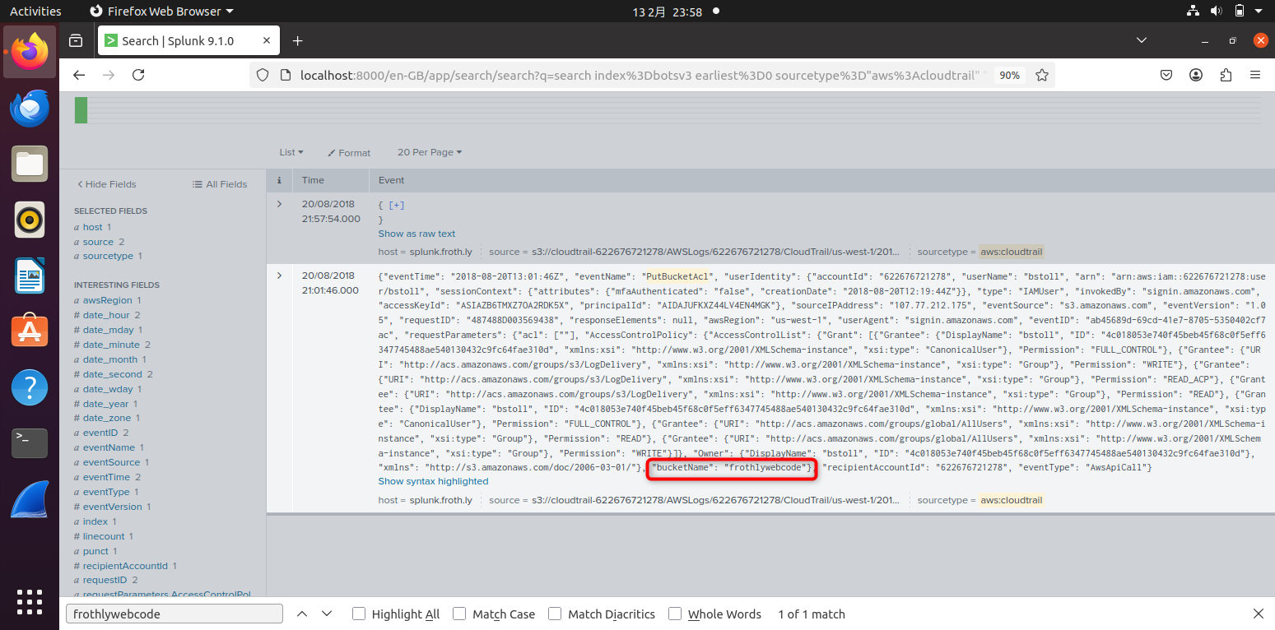 Fig.SO_CW2_Q6
Q7
Query:
index="botsv3" earliest=0 sourcetype="aws:s3:accesslogs" "*.txt"
Results(Fig.SO_CW2_Q7B):
OPEN_BUCKET_PLEASE_FIX.txt
Explanation and SOC relevance:
First of all, (using query: index="botsv3" earliest=0 sourcetype="*aws")I found that "aws:s3:accesslogs" is the access logs of aws(Fig.SO_CW2_Q7A). Then, I found that the attacker upload the file to the S3 bucket. This is the exploitation occurs. The attacker used the vulnerability (in Q4 to Q6, that is the publicly access S3 bucket) to launch an offensive.
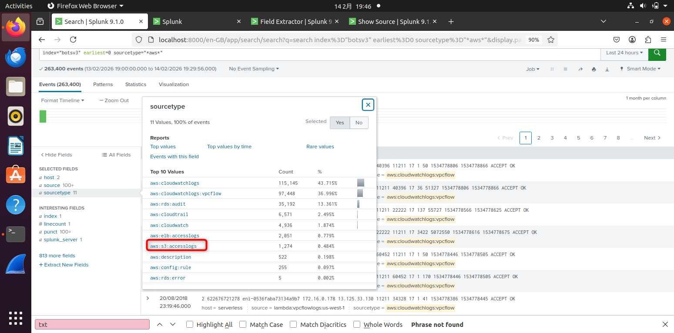Fig.SO_CW2_Q7A

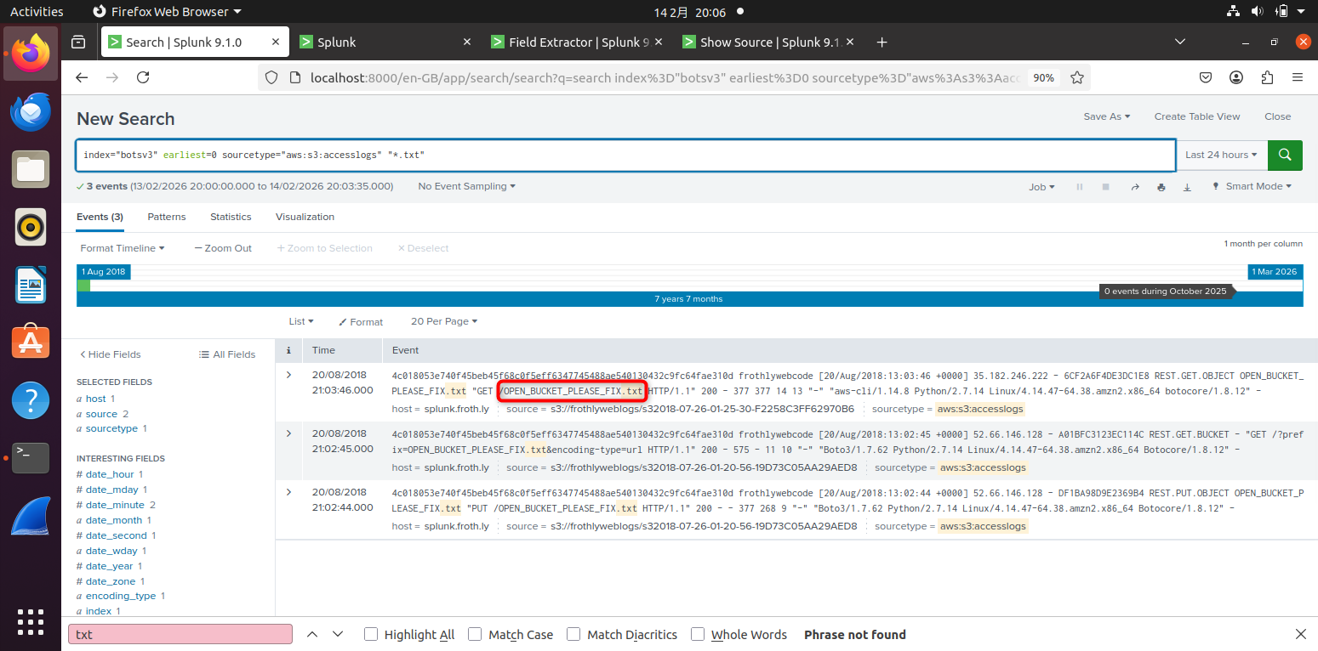 Fig.SO_CW2_Q7B
Q8
Query:
(i)
index="botsv3" earliest=0 sourcetype="winhostmon"
| stats count by OS, host
(ii)
index="botsv3" earliest=0 sourcetype="WinEventLog:Security" host="BSTOLL-L"
|head 1
|table ComputerName
Results (SO_CW2_Q8B):
BSTOLL-L.froth.ly
Explanation and SOC relevance:
Using query(i) can find out the different Windows operating systems that are running. Using query(ii) can find out its FQDN. The different Windows operating system edition is commonly used to act as attacker’s base. However, it does not prove by answers of these 8 questions.
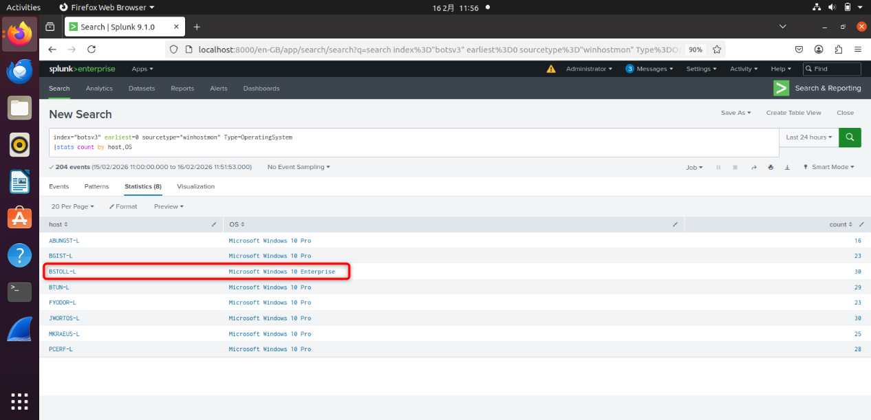 Fig.SO_CW2_Q8A
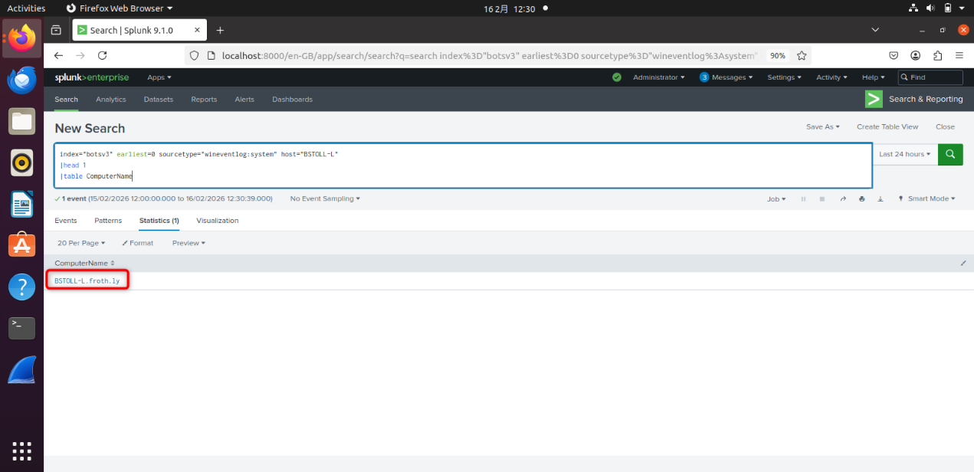Fig.SO_CW2_Q8B

(E) Conclusion
Suggestion:
Use Mfa
useS3 Block Public Access
(F) References
[1] YouTube, “YouTube,” 2026. [Online]. Available: https://www.youtube.com/watch?v=2cX-Nv0geEY. Accessed: Feb. 19, 2026.

[2] J. Gibbins, “Splunk BOTSv3 Write-Up,” James’s Peredutions, Sep. 8, 2020. [Online]. Available: https://www.jamesgibbins.com/botsv3/. Accessed: Feb. 19, 2026.

